[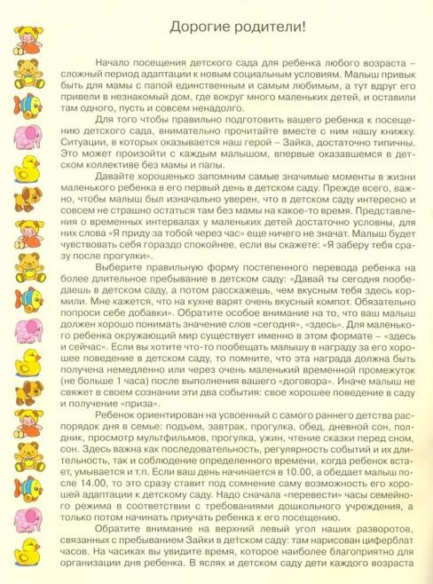](http://img0.liveinternet.ru/images/attach/c/11/116/520/116520290_large_Scan0002.jpg)

|  |
| --- |
| [Scan0002 (506x700, 331Kb)](http://img0.liveinternet.ru/images/attach/c/11/116/520/116520290_large_Scan0002.jpg)  [Scan0003 (511x700, 361Kb)](http://img1.liveinternet.ru/images/attach/c/11/116/520/116520291_large_Scan0003.jpg)  [Scan0004 (489x700, 264Kb)](http://img1.liveinternet.ru/images/attach/c/11/116/520/116520293_large_Scan0004.jpg)  [Scan0005 (502x700, 292Kb)](http://img0.liveinternet.ru/images/attach/c/11/116/520/116520294_large_Scan0005.jpg)  [Scan0006 (508x700, 257Kb)](http://img1.liveinternet.ru/images/attach/c/11/116/520/116520295_large_Scan0006.jpg)  [Scan0007 (498x700, 269Kb)](http://img0.liveinternet.ru/images/attach/c/11/116/520/116520296_large_Scan0007.jpg)  [Scan0008 (506x700, 285Kb)](http://img0.liveinternet.ru/images/attach/c/11/116/520/116520298_large_Scan0008.jpg)  [Scan0009 (508x700, 289Kb)](http://img0.liveinternet.ru/images/attach/c/11/116/520/116520302_large_Scan0009.jpg)  [Scan0010 (489x700, 264Kb)](http://img0.liveinternet.ru/images/attach/c/11/116/520/116520304_large_Scan0010.jpg)  [Scan0011 (506x700, 286Kb)](http://img1.liveinternet.ru/images/attach/c/11/116/520/116520309_large_Scan0011.jpg)  [Scan0012 (497x700, 263Kb)](http://img0.liveinternet.ru/images/attach/c/11/116/520/116520310_large_Scan0012.jpg)  [Scan0013 (510x700, 239Kb)](http://img1.liveinternet.ru/images/attach/c/11/116/520/116520313_large_Scan0013.jpg)  [Scan0014 (494x700, 268Kb)](http://img0.liveinternet.ru/images/attach/c/11/116/520/116520318_large_Scan0014.jpg)  [Scan0015 (504x700, 255Kb)](http://img0.liveinternet.ru/images/attach/c/11/116/520/116520320_large_Scan0015.jpg)  [Scan0016 (488x700, 239Kb)](http://img0.liveinternet.ru/images/attach/c/11/116/520/116520322_large_Scan0016.jpg)  [Scan0017 (502x700, 287Kb)](http://img0.liveinternet.ru/images/attach/c/11/116/520/116520324_large_Scan0017.jpg)  [Scan0018 (490x700, 288Kb)](http://img1.liveinternet.ru/images/attach/c/11/116/520/116520329_large_Scan0018.jpg)  [Scan0019 (505x700, 305Kb)](http://img0.liveinternet.ru/images/attach/c/11/116/520/116520334_large_Scan0019.jpg) |
|  |

